**Cloud Computing**

Cloud computing provides us means by which we can access the application as utilities over the internet or network. It allow us to create or install, configure base upon our requirement and custom the application online

With cloud computing uses can access database, tools, server or any product like SAP or Informatica resources via internet from anywhere for us long as they need without worrying about any maintenance as well as management of those resources.

Clouding computing provide two types of models

1. Deployment model
2. Service model

Deployment model : deployment model defines the type of access to the cloud. They again divided into 4 types.

1. Public cloud : in this type of cloud any type of user can create account and use the services base upon their requirements.

AWS, Azure, Google cloud or Oracle cloud etc.

1. Private cloud : it is type of cloud can be access with an organization.
2. Hybrid cloud : combination of public and private cloud.
3. Community cloud : n number of organization maintain by this type of cloud.

Service model : Service model are the reference of model on which the cloud is based. These can be categorized into 3 types.

1. IaaS : Infrastructure as a Service : it provide hardware as well as software configuration details.
2. PaaS : Platform as a Service : they provide us platform ie OS where we can deploy our application.
3. SaaS : Software as a Service : provide us software to run the business etc.

Cloud provided

1. **AWS**
2. **Azure**
3. **Google**
4. IBM
5. Oracle

**AWS cloud provided few modules.**

A to Z types of service.

**S3 Module**

Amazon Simple Storage Service: it is a type of service which help to share the data of any type like text file, doc file, jar or war file, project etc.

Creating spring boot project and build the project. Once you build the project it generate jar file. This jar file we will upload on S3 bucket.

If you need short or meaning full name for jar file. Please open pom.xml file and do the changes as

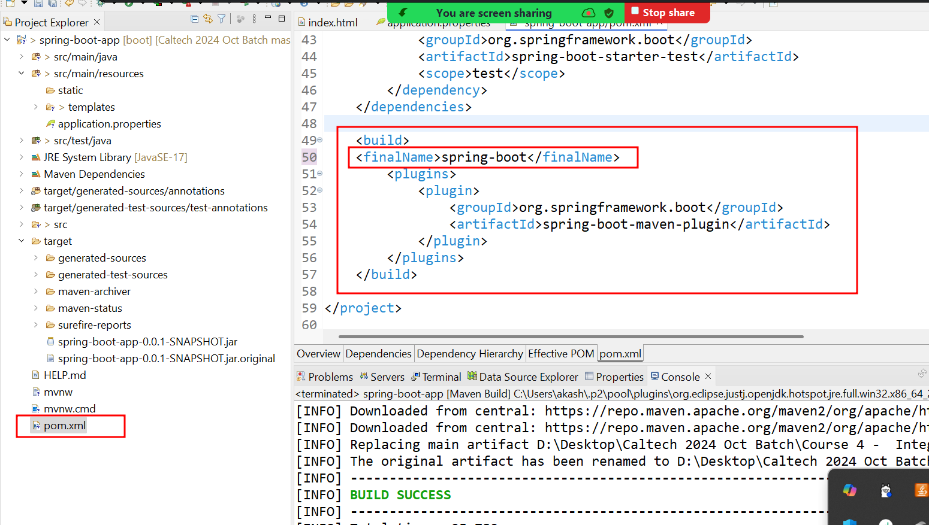

Before creating new jar file. Please do clean task. Run **maven clean**

then build and target must be **package**

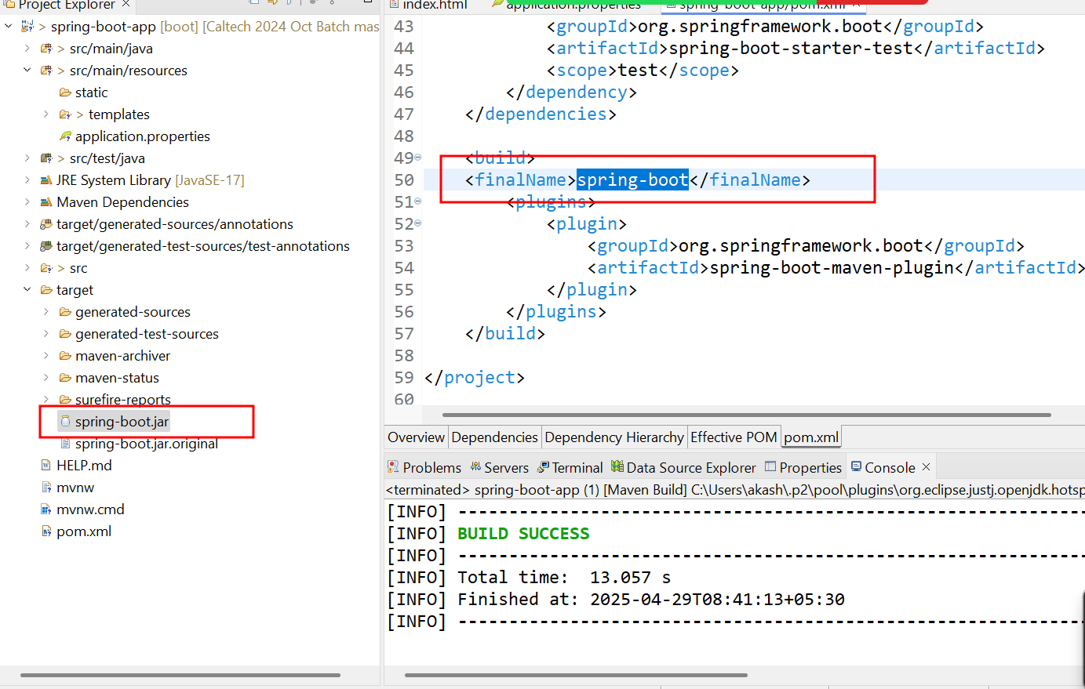

Set path

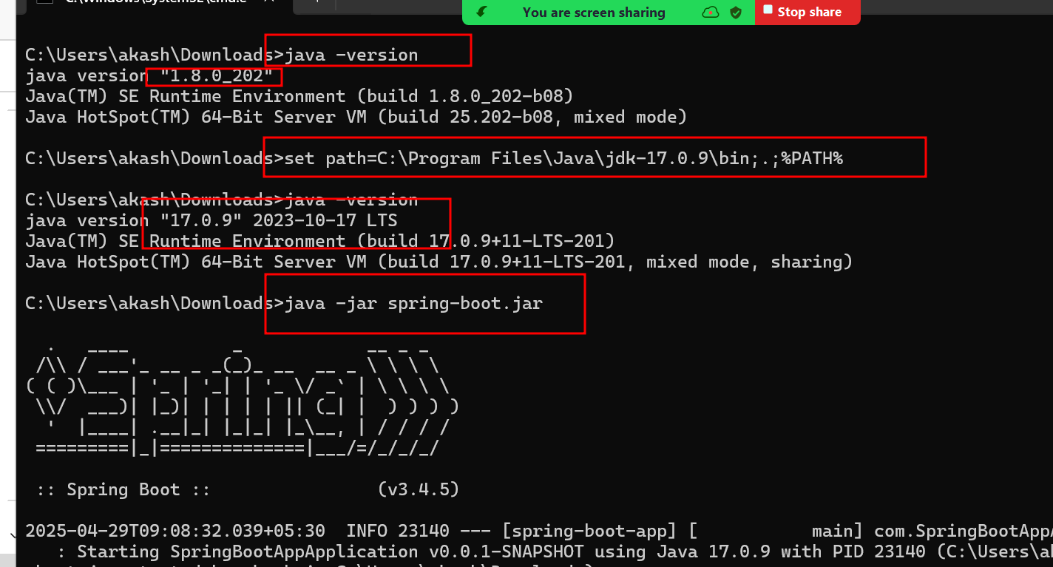

S3

AWS EC2 instance : this module help us to create Virtual Server Machine which provide public as well as private IP Address.

In EC2 instance terminal using wget S3UI

**java -jar spring-boot.jar**